nFinia Digital Banking | Summerville Credit Union | Member User Guide
Block / Unblock Card
Module: Banking › Cards › Card Status toggle

01 PRODUCT SUMMARY

The Block / Unblock Card feature lets you instantly control whether your debit or credit card can be used for new transactions. A single toggle on the Cards page — Card Status — turns your card On (active) or Off (blocked). Both actions are immediate and require a quick confirmation. You can unblock your card at any time with the same toggle.

At a Glance
Feature Name | Block / Unblock Card
Also Known As | Freeze Card, Card Status toggle
Module Location | Banking › Cards › Card Status
Who Can Use | All nFinia Digital Banking members
Block Effect | Card is immediately suspended — no new purchases, ATM withdrawals, or online transactions
Unblock Effect | Card is immediately reactivated for all transactions
Confirmation Step | A popup prompt appears before the action is applied
Availability | 24 / 7 — instant via web or mobile

02 KEY USE CASES

Use Case | Member Goal | Steps | Outcome
Block a card temporarily | Prevent unauthorized use while locating a misplaced card | Go to Cards, find the card, toggle Card Status to Off, confirm | Card is blocked immediately; can be unblocked when card is found
Unblock a card | Re-enable a card after it was temporarily blocked | Go to Cards, find the blocked card, toggle Card Status to On, confirm | Card is active again for all transactions
Block card on suspicion | Stop potential fraud without deactivating the card permanently | Toggle Card Status Off; monitor account activity; unblock if resolved | Card suspended quickly without requiring a replacement
Unblock after false alarm | Restore card access after confirming safety | Toggle Card Status back to On and confirm | Normal card access restored without any wait

03 STEP-BY-STEP GUIDE

📍 Navigation path: Banking › Cards

■ Blocking Your Card (Card Status: On → Off)

Step 1 Go to your Cards
From the nFinia home screen, select Cards in the top navigation bar. Your enrolled cards are listed with their card number, expiry, and current Card Status.
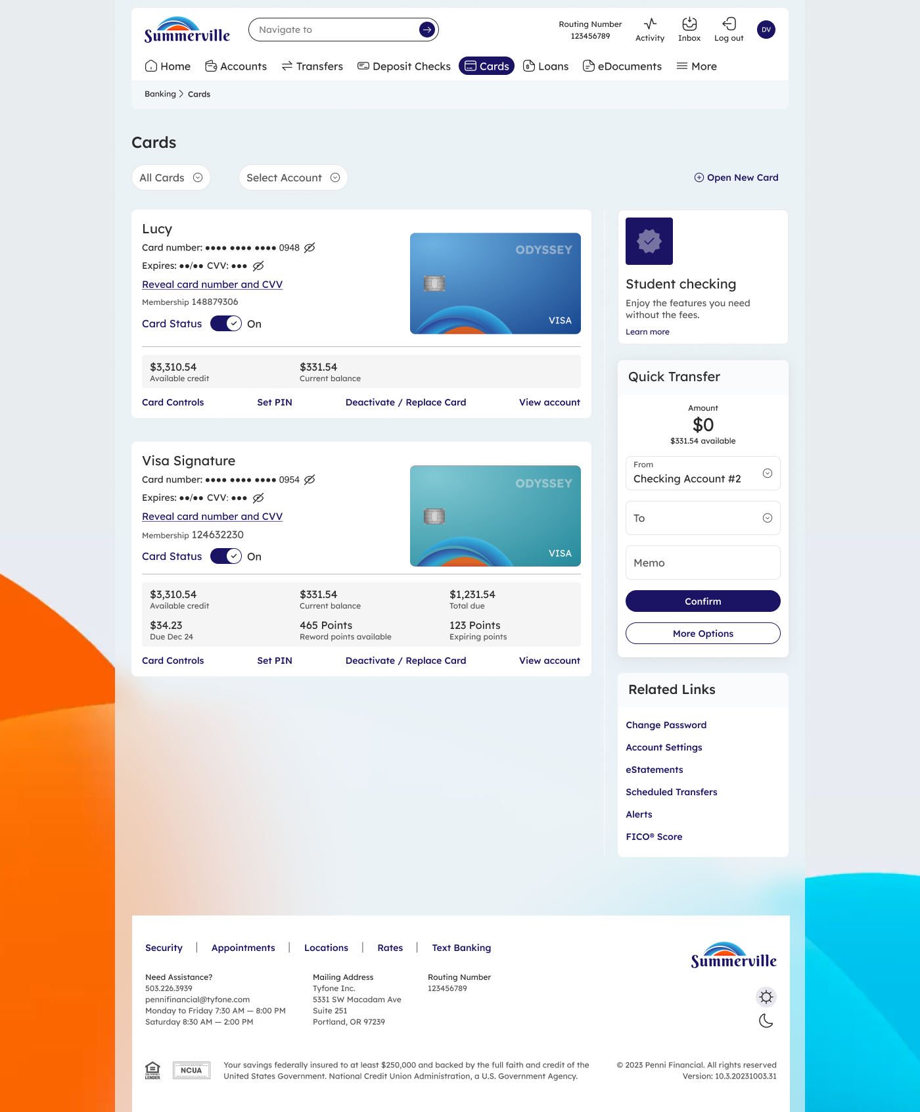

Step 2 Toggle Card Status to Off
Locate the card you want to block. Click the Card Status toggle — it will switch from On (blue/active) to Off. A confirmation prompt immediately appears asking you to confirm the block.
⚠️ Note: Blocking your card prevents ALL new transactions instantly, including scheduled or recurring payments linked to this card.

Step 3 Confirm the Block
Review the confirmation popup. It will show the last 4 digits of the card being blocked. Click Yes to confirm, or No to cancel without making any change.

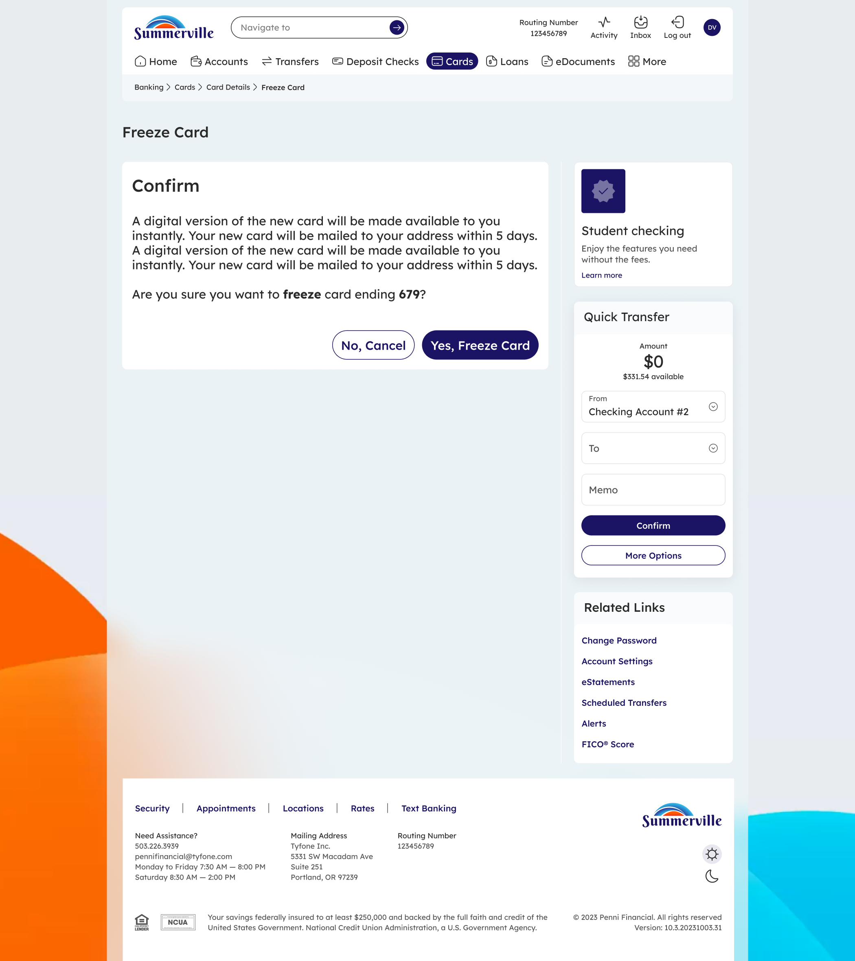

ℹ️ Tip: After blocking, the Card Status toggle on the Cards page will show Off, so you always know which cards are currently suspended.

■ Unblocking Your Card (Card Status: Off → On)

Step 1 Go to your Cards
Navigate to Banking › Cards. A blocked card will show Card Status: Off.

Step 2 Toggle Card Status to On
Click the Card Status toggle on the blocked card. It will switch from Off back to On (active). A confirmation prompt will appear asking you to confirm the unblock.

Step 3 Confirm the Unblock
In the confirmation popup, verify the card's last 4 digits and click Yes to reactivate. Your card is immediately ready for transactions once confirmed.

ℹ️ Tip: Unblocking is instant — there is no waiting period. Your card can be used for purchases, ATM withdrawals, and online payments right away.

